
Employee Onboarding Automation System


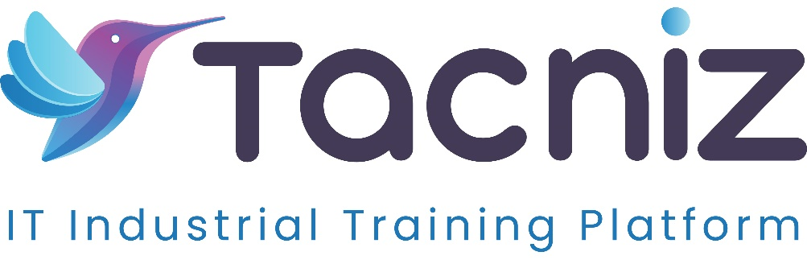

Problem Statement
Traditional employee onboarding processes are often manual, time-consuming, and prone to errors, especially when dealing with multiple new hires. HR teams spend significant time managing paperwork, tracking task completion, and ensuring employees are trained on company policies. A digital onboarding system can automate the entire process, allowing new employees to complete their onboarding remotely while ensuring that all necessary documents, tasks, and training are completed efficiently.

Project Type
- Type: HR Automation System
- Category: Employee Onboarding, Digital Forms, Workflow Automation

Industry Area
- Industry: Corporate, IT, Healthcare, Education
- Relevant Sectors: HR Management, Talent Acquisition, Workforce Management

Software Expertise Required
- Frontend Development: HTML, CSS, JavaScript (React, Vue, or Angular) to create user-friendly onboarding forms, task-tracking dashboards, and training modules.
- Backend Development: Node.js / Python (Django/Flask) for managing document uploads, workflow automation, and tracking task completion.
- Cloud Integration: AWS, Google Cloud, or Azure for securely storing employee documents, training progress, and onboarding tasks in real-time.
- Document Management and E-Signatures: Integration with e-signature services (e.g., DocuSign) for digitally signing contracts, policy acknowledgments, and HR documents.
- Mobile App Development: React Native or Flutter to create a mobile-friendly version of the onboarding platform so employees can complete onboarding tasks on the go.
- Security and Privacy: SSL/TLS encryption, user authentication, and role-based access control to ensure sensitive HR data is securely stored and accessed only by authorized personnel.

Use Cases
- HR Teams: Automate the onboarding process, assign tasks to new hires, track their progress, and store important documents securely in the system.
- New Employees: Complete onboarding tasks, fill out digital forms, sign documents, and participate in training modules remotely, making the transition to the company smoother and more efficient.
- Managers: Track the onboarding status of their new team members, ensuring that they are completing tasks on time and getting the necessary training before starting their role.

Expected Outcomes
- Seamless Digital Onboarding: New employees can complete all onboarding tasks remotely, including signing documents, completing training, and filling out required forms.
- Automated Task Tracking: HR teams can assign and track onboarding tasks in real-time, ensuring that no step in the process is missed and providing automated reminders for incomplete tasks.
- Efficient Document Management: New hires can upload necessary documents (e.g., identification, tax forms) and sign digital contracts securely through the platform.
- Training and Policy Compliance: The system can deliver company policy training and track completion, ensuring that employees understand and comply with all necessary regulations before they start their role.

Key Features
- Digital Forms and Document Upload: New hires can fill out onboarding forms and upload necessary documents through a secure portal, reducing the need for physical paperwork.
- Task Tracking Dashboard: Both HR teams and new hires can view assigned onboarding tasks (e.g., complete training, submit tax forms, sign contract) and track their progress in real-time.
- E-Signature Integration: The system can integrate with e-signature platforms like DocuSign to allow new hires to digitally sign offer letters, contracts, and policy acknowledgments.
- Training Modules and Compliance Tracking: The system can host or link to training modules (e.g., workplace safety, compliance) and track when employees complete each section, providing HR with real-time updates on progress.
- Automated Reminders and Notifications: Automated notifications can remind new hires to complete tasks, notify HR of missing documents, or alert managers when onboarding is complete.
- Mobile Access: The onboarding system is mobile-friendly, allowing new hires to complete tasks, sign documents, and participate in training via their mobile devices.

Benefits
- Efficiency: Automates the onboarding process, reducing manual HR work and ensuring that new hires have all the tools they need to get started quickly.
- Flexibility: New hires can complete the entire onboarding process remotely, which is especially beneficial for companies with remote or hybrid work models.
- Improved Compliance: Tracks training completion, policy acknowledgment, and document submission, ensuring that all compliance requirements are met before the employee starts.
- Better Employee Experience: New hires are able to complete the onboarding process at their own pace, with clear instructions and reminders, reducing the stress associated with the onboarding process.
- Time Savings: HR teams save time by automating repetitive tasks like sending reminders, collecting documents, and tracking task completion, allowing them to focus on other high-priority tasks.

Project Duration
- Estimated Duration: 5-6 Months.

